Lecture # 21:

Objective:

* OLEDB (ACCESS) Database Connectivity (CONNECTED)

o IDU and SELECT Queries Example

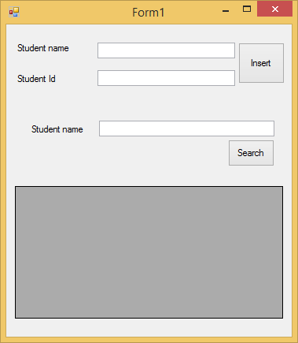

using System;

using System.Collections.Generic; using System.ComponentModel; using System.Data;

using System.Drawing; using System.Linq; using System.Text;

using System.Windows.Forms; using System.Data.OleDb;

namespace oledbconnected

{

public partial class Form1 : Form

{

public Form1()

{

InitializeComponent();

}

private void btnInsert_Click(object sender, EventArgs e)

{

string strcon = @"---";

OleDbConnection con = new OleDbConnection(strcon); con.Open();

string query = "insert into stdInfo values (" + textid.Text + ",'" + textname.Text + "')";

OleDbCommand cmd = new OleDbCommand(query, con); cmd.ExecuteNonQuery();

}

private void btnsearch_Click(object sender, EventArgs e)

{

string strcon = @"---";

OleDbConnection con = new OleDbConnection(strcon); con.Open();

string query = "select * from stdInfo where name like'" + textname.Text + "%'";

OleDbCommand cmd = new OleDbCommand(query, con);

OleDbDataAdapter oda = new OleDbDataAdapter(cmd); DataSet ds = new DataSet();

oda.Fill(ds);

dataGridView1.DataSource = ds.Tables[0];

}

}

}